
FPT UNIVERSITY

Taxi Caller Application on Windows Phone
F_Taxi
Report #3 – Software Requirements Specification
F_Taxi
Group Member | SE02705 - Phạm Gia Hữu
Group Member | SE02900 - Tạ Thiên Hưởng
Group Member | SE02268 - Phạm Ngọc Hoàn
Group Member | SE02314 - Nguyễn Văn Lập
Supervisor | Nguyễn Văn Sang
Project Code | F_Taxi

HaNoi, 10/2015
Table of Contents
1 Introduction 3
1.1 Purpose 3
1.2 Scope 3
1.3 Definitions, Acronyms and Abbreviations 3
1.4 References 4
1.5 Overview 4
2 Overall Description 5
2.1 Product Perspective 5
2.2 Product Function 5
2.3 User Characteristics 6
2.4 Constraints 6
2.5 Assumption and Dependencies 6
3 Specific Requirement 6
3.1 External Interface Requirement 6
3.1.1 User Interfaces 6
3.1.2 Hardware Interfaces 7
3.1.3 Software Interfaces 7
3.2 Functional Requirements 7
3.2.1 List User Case 7
3.2.2 User Case Specification 10
3.3 Non-functional Requirement 54
3.3.1 Reliability 54
3.3.2 Performance Requirement 54

Introduction
This chapter outlines functional and nonfunctional requirements of the product F_Taxi. It also provides some format constraints in common requirements and project success criteria. All member’s works (designing, coding, and testing) will be based on the information provided in this chapter.

Purpose
This report fully describes the external behavior of the application or subsystem identified. It also describes nonfunctional requirements, design constraints, and other factors necessary to provide a complete and comprehensive description of the requirements for release version v.1.0 of the software. This document is to be used by members of project team to implement and verify correct function of the system. Except other notes, all requirements of the system are specified here are high priority and committed for release v.1.0.

Scope
F-Taxi is windows phone application help user get a trip using taxi easily with a fully detailed of trip and low price. With a few touch from user hand, user can easy get understand how application work and friendly user interfaces.

Definitions, Acronyms and Abbreviations
Acronyms | Description | Note
F-Taxi | Taxi Caller Application
PM | Project Manager
PTL | Project Technical Leader
QA | Quality Assurance
CM | Configuration Management
TL | Test Leader
SRS | Software Requirement Specification
Specs | Specification
GUI | Graphic User Interface
TD | Test Design
TP | Test Plan
TC | Test Case
TR | Test Report
UT | Unit Test
ST | System Test
AT | Acceptance Test
Guest | Visitor who has not logged in the application
Rider | Person who has logged in the application as Rider
Driver | Person who has logged in the application as Driver
GPS | Global Positioning System
App | Application
Stakeholder | Any person who has interaction with the system

References
[1] BY group, BY Capstone Project Document, FPT University, Hanoi, Vietnam.
[2] SRS FPT Software template

Overview
This remainder of this document includes three chapters and appendixes. The second one provides an overview of the system functionality and system interaction with other systems. This chapter also introduces different types of stakeholders and their interaction with the system. Further, the chapter also mentions the system constraints and assumptions about the product. The third chapter provides the requirements specification in detail terms and a description of the different system interfaces. Different specification techniques are used in order to specify the requirements more precisely for different audiences. The fourth chapter deals with the prioritization of the requirements. It includes a motivation for the chosen prioritization methods and discusses why other alternative were not chosen. The Appendixes in the end of the document include the all results of the requirement prioritization and a release plan based on them.

Overall Description
This section will give an overview of the whole system. The system will be explained in its context to show how the system interacts with other systems and introduce the basic functionality of it. It will also describe what type of stakeholders that will use the system and what functionality is available for each type. At last, the constraints and assumptions for the system will be presented.
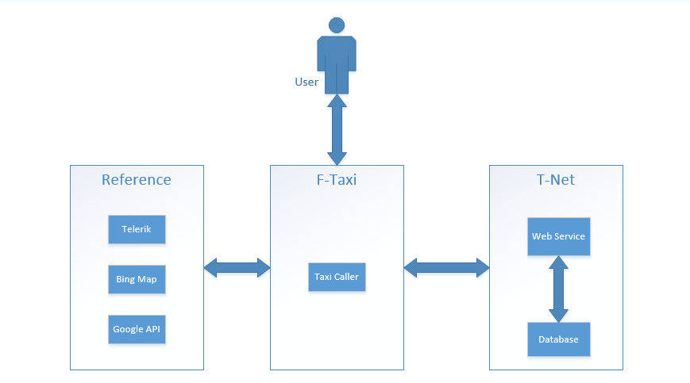
Figure 2. Overall system

Product Perspective
This windows phone application for two main user is Rider and Driver can using full features of application and communicate to each other.

Product Function
The main function of application is help two main user is Rider and Driver communicate easy on windows phone mobile application.
- Rider:
  - Authenticate
  - Manage Profile
  - Manage Favorite
  - Interact with Trip
  - Find Lost Asset
  - Call Taxi Center
  - Send Application Feedback
- Driver
  - Authenticate
  - Manage Profile
  - Manage Vip Customer
  - Interact with Trip
  - Notification Lost Asset
  - Change Status

User Characteristics
In the application, it have three classes of user that’s interact with application:
- Guest: only register.
- Driver: using as driver taxi.
- Rider: take a trip on taxi.

Constraints
The internet connection is a constraint for the application. Since the application fetches data from the database over the internet, it is crucial that there is an internet connection for the application to functions.

Assumption and Dependencies
The product will always be used on mobile phones that have enough performance. If the phone does not have enough hardware resources available for the application, for example the users might have allocated them with other applications, there may be scenarios where the application does not work as intended or even at all.

Specific Requirement

External Interface Requirement

User Interfaces
- User interface should be easy to understand and easily to use.
- The text and color is attractive for all user.

Hardware Interfaces
- Using Windows Phone with 8.0 version

Software Interfaces
- Windows Phone OS 8.1 or simulated in desktop.

Functional Requirements

List User Case

Guest and Rider
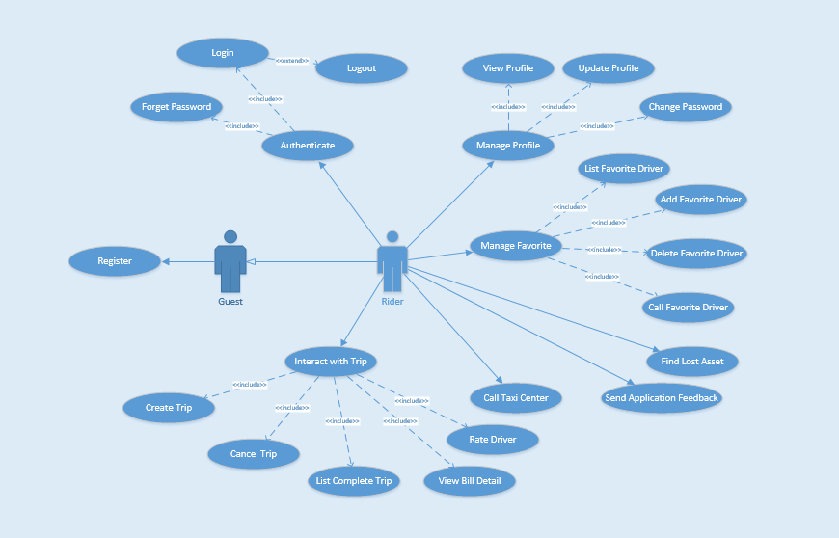
Guest and Rider User Case Diagram
Use Case ID | Actor | Group of function | Name | Note
UC-01 | Guest |  | Register
UC-02 | Rider | Authenticate | Login
UC-03 | Rider | Authenticate | Logout
UC-04 | Rider | Authenticate | Forget Password
UC-05 | Rider | Manage Profile | View Profile
UC-06 | Rider | Manage Profile | Update Profile
UC-07 | Rider | Manage Profile | Change Password
UC-08 | Rider | Manage Favorite | List Favorite Driver
UC-09 | Rider | Manage Favorite | Add Favorite Driver
UC-10 | Rider | Manage Favorite | Delete Favorite Driver
UC-11 | Rider | Manage Favorite | Call Favorite Driver
UC-12 | Rider |  | Find Lost Asset
UC-13 | Rider |  | Send Application Feedback
UC-14 | Rider |  | Call Taxi Center
UC-15 | Rider | Interact with Trip | Create Trip
UC-16 | Rider | Interact with Trip | Cancel Trip
UC-17 | Rider | Interact with Trip | List Complete Trip
UC-18 |  | Interact with Trip | View Bill Detail
UC-19 |  | Interact with Trip | Rate Driver

Driver
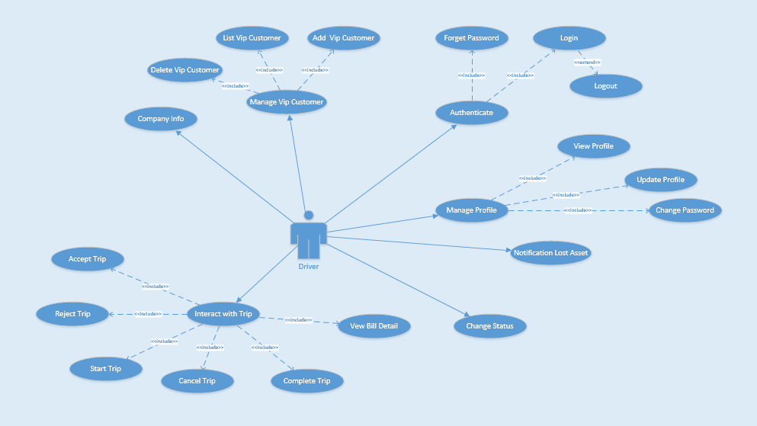
Use Case ID | Actor | Group of function | Name | Note
UC-18 | Driver | Authenticate | Login
UC-19 | Driver | Authenticate | Logout
UC-20 | Driver | Authenticate | Forget Password
UC-21 | Driver | Authenticate | View Profile
UC-22 | Driver | Manage Profile | Update Profile
UC-23 | Driver | Manage Profile | Change Password
UC-24 | Driver | Manage Profile | Company Info
UC-25 | Driver | Manage Vip Customer | List Vip Customer | To be defined
UC-26 | Driver | Manage Vip Customer | Add Vip Customer | To be defined
UC-27 | Driver | Manage Vip Customer | Delete Vip Customer | To be defined
UC-28 | Driver |  | Notification Lost Asset
UC-29 | Driver |  | Change Status
UC-30 | Driver | Interact with Trip | Accept Trip
UC-31 | Driver | Interact with Trip | Reject Trip
UC-32 | Driver | Interact with Trip | Start Trip
UC-33 | Driver | Interact with Trip | Cancel Trip
UC-34 | Driver | Interact with Trip | Complete Trip
UC-35 |  | Interact with Trip | View Bill Detail

User Case Specification

Guest and Rider

UC-01 Register
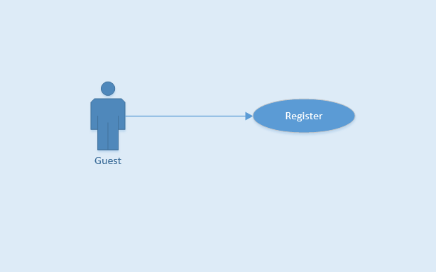
Use Case ID |  |  | UC-01
Use Name |  |  | Register
Actor |  |  | Guest
Description |  |  | Guest can register account to have a valid user in system
Precondition |  |  | Have a valid email address
Trigger |  |  | Tap on “Đăng ký” button, “tick” icon and click on activation link
Post-Condition |  |  | Rider account information is stored in database
Main flows
Step | Actor |  | Action
1 | Guest |  | Tap on “Đăng ký” button on Login screen
2 | F-Taxi |  | Display Login screen with the following fields:  - User Name/Email  - Password  - Password Again  - First Name  - Last Name  - Phone Number
3 | Guest |  | Enter “Email”, “Mật khẩu”, “Nhập lại mật khẩu” , “Tên đệm”, “Tên ”, “Số ĐT” fields on the Register screen, then tap on “Đăng ký” icon.
4 | F-Taxi |  | Validate the entered by Guest and show "Đăng ký thành công!" message, then display Login screen
Alternative flows
AT1 |  | At step 4 in the main flows, if guest insert wrong “Nhập lại mật khẩu”, wrong email format, or keep mandatory field blank
Step |  | Actor |  | Action
4.1 |  | F-Taxi |  | Display message to warning about wrong information and require enter again
AT2 |  | Display message that email has existed, and require guest to change email
Step |  | Actor |  | Action
4.1 |  | F-Taxi |  | Display message that email has existed, and require guest to change email

Business Rules
# | Rule Description
BR01 | Need Internet connection.
BR02 | All field is required

UC-02 Login
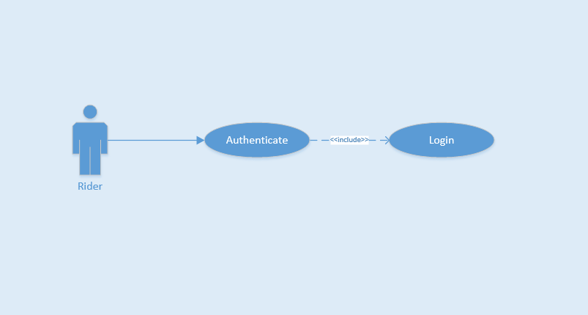
Use Case ID |  |  | UC-02
Use Name |  |  | Login
Actor |  |  | Rider
Description |  |  | This function allows a Rider to be able to login the application when he/she have registered an account and his/her account is active
Precondition |  |  | Start screen
Trigger |  |  | Input email and password correctly in the right textbox then tap on “Đăng nhập” button
Post-Condition |  |  | Login successfully
Main flows
Step | Actor |  | Action
1 | Rider |  | Tap on “Bỏ qua để đăng nhập” button on Start screen
2 | F-Taxi |  | Display Login screen with the following fields:  - Email  - “Mật khẩu”  - “Đăng nhập” button  - “Quên mật khẩu?” text block
3 | Rider |  | Enter Email and “Mật khẩu” fields on the Login screen, then tap on “Đăng nhập” icon.
4 | F-Taxi |  | Validate the entered Email and “Mật khẩu” and then display Home screen
Alternative flows
AT1 |  | At step 4 in the main flows, if F-Taxi failed to validate username and password
Step |  | Actor |  | Action
4.1 |  | F-Taxi |  | Display "Login" page with message "Email hoặc mật khẩu không đúng”

Business Rules
# | Rule Description
BR01 | Email must match xxx@xxx.xxx form
BR02 | Password must be show as asterisk (*******) type
BR03 | Need Internet connection.

UC-03 Logout
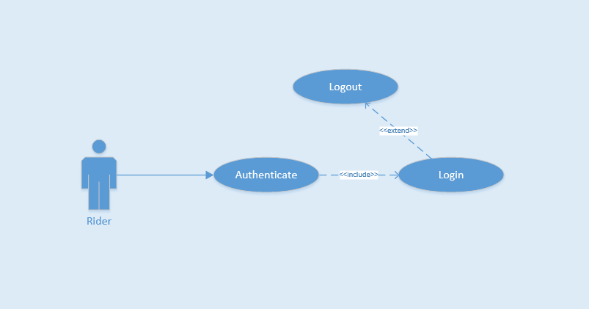
Use Case ID |  |  | UC-03
Use Name |  |  | Logout
Actor |  |  | Rider
Description |  |  | This function allows a Rider to logout F-Taxi
Precondition |  |  | Login
Trigger |  |  | Tap on back button or tap on “Đăng xuất” icon in menu bar, and then tap “Có” or tap on “Đăng xuất” icon and then tap “Có”
Post-Condition |  |  | Logout successfully
Main flows
Step | Actor |  | Action
1 | Rider |  | On Home screen, tap on back button or tap on “Đăng xuất” icon in menu bar
2 | F-Taxi |  | Display confirm message box with message “Bạn có muốn thoát không?”
3 | Rider |  | Tap “Có” option on message box
4 | F-Taxi |  | Log user out and display Login screen
Alternative flows
AT1 |  | At step 3 in the main flows, if Rider tap “Không” option on message box
Step |  | Actor |  | Action
3.1 |  | F-Taxi |  | Display "Login" page with message "Email hoặc mật khẩu không đúng”

Business Rules
# | Rule Description
BR01 | Need Internet connection.

UC-04 Forget Password
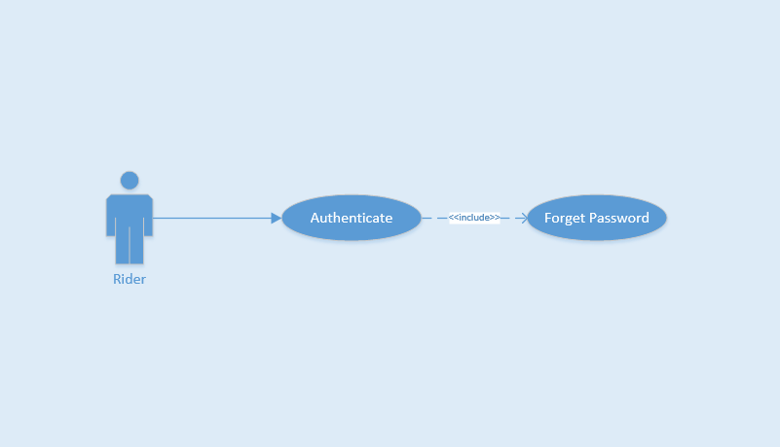
Use Case ID |  |  | UC-04
Use Name |  |  | Forget Password
Actor |  |  | Rider
Description |  |  | The function allows an Rider create new password
Precondition |  |  | Start app
Trigger |  |  | Tap on “Quên mật khẩu?” text on Login screen
Post-Condition |  |  | Reset password and create new password
Main flows
Step | Actor |  | Action
1 | Rider |  | On Login screen, tap on “Quên mật khẩu?” text
2 | F-Taxi |  | Display Forget Password screen
3 | Rider |  | Enter email to Email field, tap on “Đặt lại mật khẩu” icon
4 | F-Taxi |  | Show "Mật khẩu đã được gửi về hôm thư của bạn. Vui lòng kiếm tra và đăng nhập lại!" message and send email confirm for Rider
Alternative flows
AT1 |  | At step 3 in the main flows, if Rider tap back button
Step |  | Actor |  | Action
3.1 |  | F-Taxi |  | Display "Login" screen

Business Rules
# | Rule Description
BR01 | Need Internet connection.

UC-05 View Profile
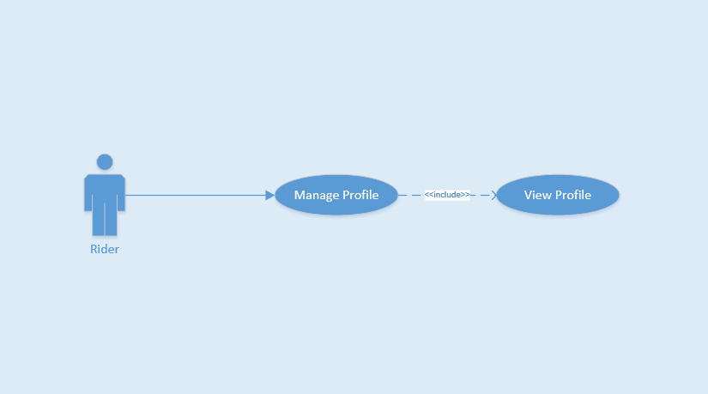
Use Case ID |  |  | UC-05
Use Name |  |  | View Profile
Actor |  |  | Rider
Description |  |  | This function allows Rider view profile
Precondition |  |  | Login and on Home Page Screen
Trigger |  |  | Tap on top left menu and then tap on image or name of Rider
Post-Condition |  |  | View successful
Main flows
Step | Actor |  | Action
1 | Rider |  | In Home Page screen, tap on top left menu
2 | F-Taxi |  | Show list left menu
3 | Rider |  | Tap on image or name of Rider
4 | F-Taxi |  | View successful
Alternative flows
AT1 |  | At step 3 in the main flows, if Rider tap button back
Step |  | Actor |  | Action
3.1 |  | F-Taxi |  | Back to Home Page Screen

Business Rules
# | Rule Description
BR01 | Need Internet connection.

UC-06 Update Profile
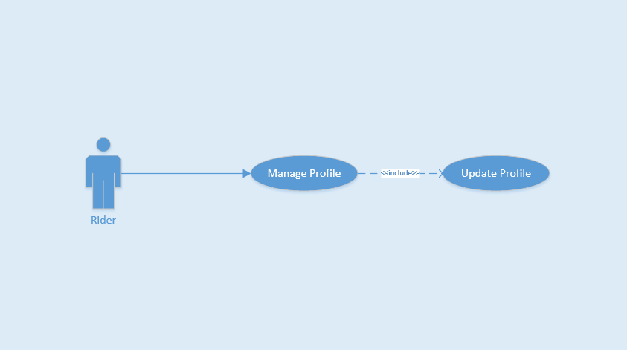
Use Case ID |  |  | UC-06
Use Name |  |  | Update Profile
Actor |  |  | Rider
Description |  |  | The function allows Rider to change their profile
Precondition |  |  | Login and on Home Page Screen
Trigger |  |  | Tap on field want to change and update field
Post-Condition |  |  | Updated successfully
Main flows
Step | Actor |  | Action
1 | Rider |  | On Home Page screen, tap on avatar or name of menu bar
2 | F-Taxi |  | Display Profile screen
3 | Rider |  | Tap on field want to change and update field, then tap on “Lưu” button.
4 | F-Taxi |  | Display message notice changed successfully. Stayed on Rider Profile page
5 | Rider |  | Tap on pencil image to change home or work address
6 | F-Taxi |  | Show Add Home Place or Add Work Place page
7 | Rider |  | Enter address textbox and choose right place from suggest to auto complete address
8 | F-Taxi |  | Show marker on maps.
9 | Rider |  | Tap on “Lưu lại” button
10 | F-Taxi |  | Display "Cập nhật thông tin cá nhân thành công!" message notice changed successfully
Alternative flows
AT1 |  | At step 3 in the main flows, if Rider enter wrong information form
Step |  | Actor |  | Action
3.1 |  | F-Taxi |  | Display message box remind Rider insert again

Business Rules
# | Rule Description
BR01 | Need Internet connection.

UC-07 Change Password
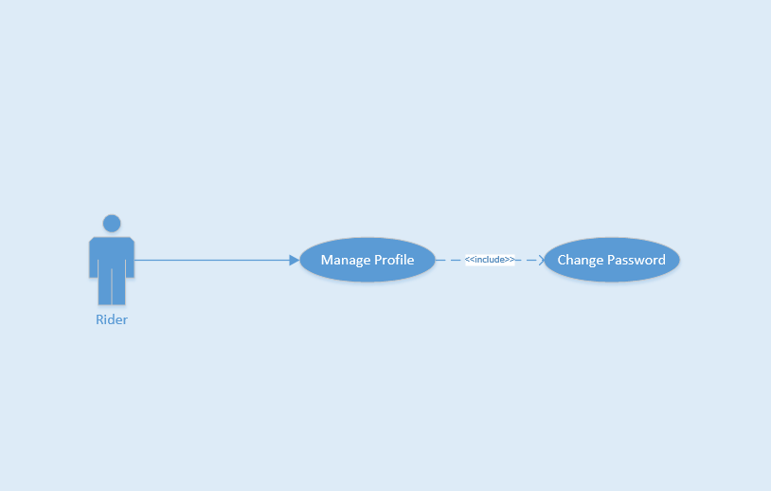
Use Case ID |  |  | UC-07
Use Name |  |  | Change Password
Actor |  |  | Rider
Description |  |  | The function allows a Rider to change their password
Precondition |  |  | Login and on Home Page Screen
Trigger |  |  | Tap on “Đổi mật khẩu” text and enter all field to change, then tap on “Xác nhận thay đổi” icon.
Post-Condition |  |  | Changed successfully
Main flows
Step | Actor |  | Action
1 | Rider |  | On Home Page screen, tap on avatar or name on left menu
2 | F-Taxi |  | Display Profile screen
3 | Rider |  | Tap on “Đổi mật khẩu” text
4 | F-Taxi |  | Display Change password screen with the following fields:  - “Mật khẩu cũ”  - “Mật khẩu mới”  - “Nhập lại mật khẩu mới”
5 | Rider |  | Enter “Mật khẩu cũ”, “Mật khẩu mới”, “Nhập lại mật khẩu mới” field on Change Password screen and then tap on “Đặt lại mật khẩu”.
6 | F-Taxi |  | Display a message box notice changed successfully
Alternative flows
AT1 |  | At step 4 in the main flows, if Rider insert wrong format password
Step |  | Actor |  | Action
4.1 |  | F-Taxi |  | Display message box remind Rider insert again

Business Rules
# | Rule Description
BR01 | Need Internet connection.

UC-08 List Favorite Driver
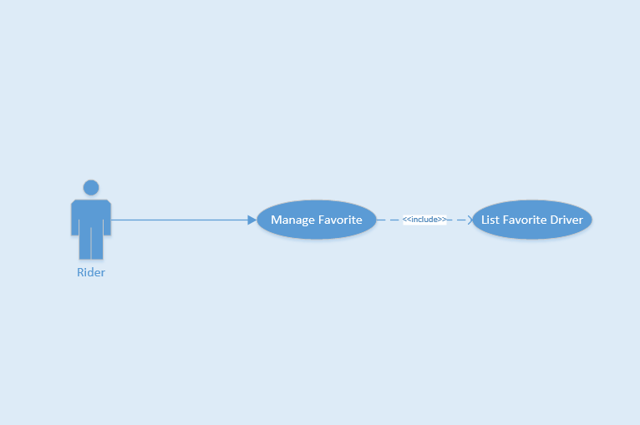
Use Case ID |  |  | UC-08
Use Name |  |  | List Favorite Driver
Actor |  |  | Rider
Description |  |  | This function allows Rider show list favorite Driver
Precondition |  |  | Login and on Home Page Screen
Trigger |  |  | Tap on “Tài xế ưa thích” on left menu
Post-Condition |  |  | Show list successful
Main flows
Step | Actor |  | Action
1 | Rider |  | On Home Page screen, “Tài xế ưa thích” on left menu
2 | F-Taxi |  | Show list favorite Driver
Alternative flows
AT1 |  | At step 2 in the main flows, if Rider has no favorite Driver
Step |  | Actor |  | Action
2.1 |  | F-Taxi |  | Show "Chưa có thông tin!" message

Business Rules
# | Rule Description
BR01 | Need Internet connection.

UC-09 Add Favorite Driver
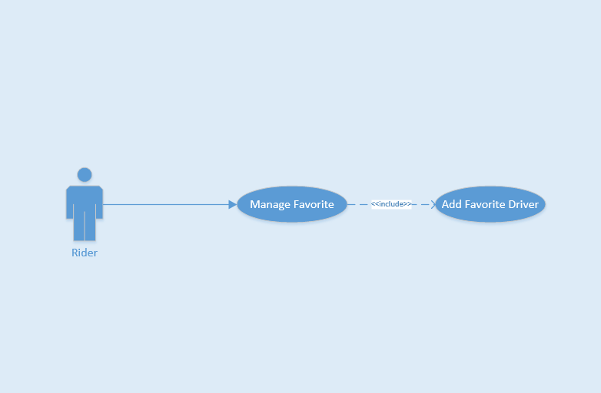
Use Case ID |  |  | UC-09
Use Name |  |  | Add Favorite Driver
Actor |  |  | Rider
Description |  |  | This function allows Rider add favorite Driver
Precondition |  |  | Finished Trip
Trigger |  |  | Tap on Add Favorite button on detail bill
Post-Condition |  |  | Add favorite Driver successful
Main flows
Step | Actor |  | Action
1 | F-Taxi |  | Show detail bill on screen
2 | Rider |  | Tap on “Thêm vào yêu thích” button
3 | F-Taxi |  | Show "Bạn đã thêm thành công lái xe yêu thích!" and add favorite Driver successful
4
Alternative flows
Step |  | Actor |  | Action

Business Rules
# | Rule Description
BR01 | Need Internet connection.

UC-10 Delete Favorite Driver
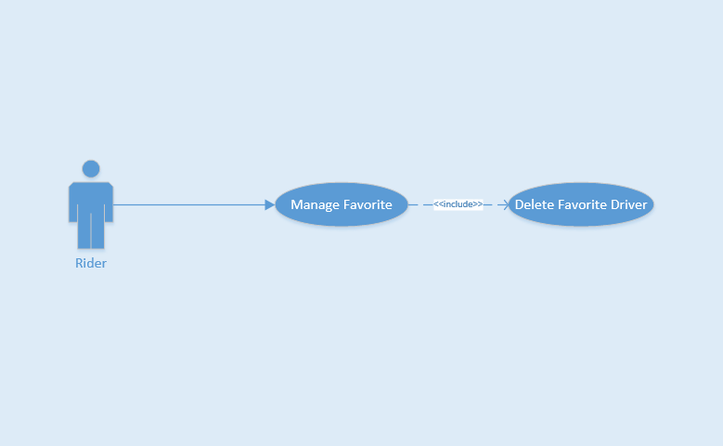
Use Case ID |  |  | UC-10
Use Name |  |  | Delete Favorite Driver
Actor |  |  | Rider
Description |  |  | This function allows Rider delete favorite Driver
Precondition |  |  | Login and on Home Page Screen
Trigger |  |  | Tap on favorite Driver and tap on “Xóa khỏi danh sách” button
Post-Condition |  |  | Delete favorite Driver Successful
Main flows
Step | Actor |  | Action
1 | Rider |  | On Home Page screen, “Tài xế ưa thích” on left menu
2 | F-Taxi |  | Show list favorite Driver
3 | Rider |  | Choose Driver and tap on, then tap on “Xóa khỏi danh sách”
4 | F-Taxi |  | Delete favorite Driver successful
Alternative flows
AT1 |  | At step 3 in the main flows, if Rider tap on “ Hủy” button
Step |  | Actor |  | Action
3.1 |  | F-Taxi |  | Back to List Favorite Driver page

Business Rules
# | Rule Description
BR01 | Need Internet connection.

UC-11 Call Favorite Driver
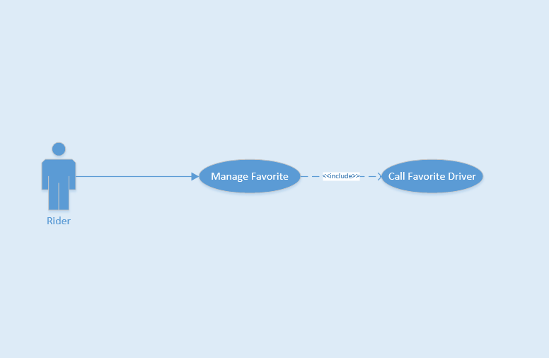
Use Case ID |  |  | UC-11
Use Name |  |  | Call Favorite Driver
Actor |  |  | Rider
Description |  |  | This function allows Rider call favorite Driver instantly
Precondition |  |  | Login and on Home Page Screen
Trigger |  |  | Tap on favorite Driver and tap on “Gọi tài xế” button
Post-Condition |  |  | Call favorite Driver successful
Main flows
Step | Actor |  | Action
1 | Rider |  | On Home Page screen, tap on “Tài xế ưa thích” on left menu
2 | F-Taxi |  | Show list favorite Driver
3 | Rider |  | Choose Driver and tap on, then tap on “Gọi tài xế”
4 | F-Taxi |  | Call favorite Driver successful
Alternative flows
AT1 |  | At step 3 in the main flows, if Rider tap on “ Hủy” button
Step |  | Actor |  | Action
3.1 |  | F-Taxi |  | Back to List Favorite Driver page

Business Rules
# | Rule Description
BR01 | Need Internet connection.

UC-12 Find Lost Asset
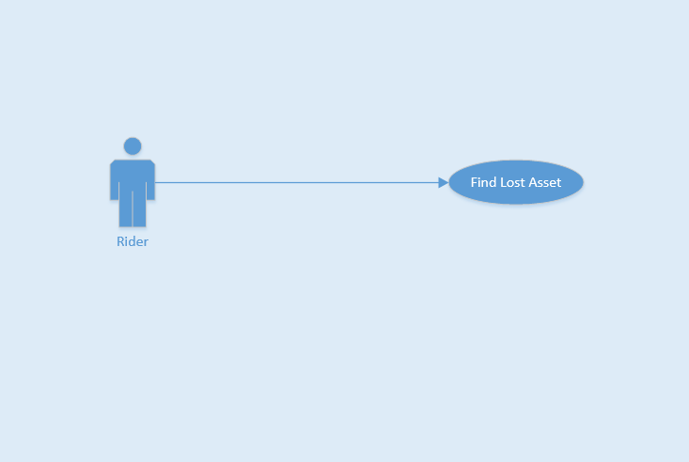
Use Case ID |  |  | UC-12
Use Name |  |  | Find Lost Asset
Actor |  |  | Rider
Description |  |  | This function allows Rider find lost asset after finished trip
Precondition |  |  | Finished Trip and on Home Page screen
Trigger |  |  | Tap on trip and enter message , then send the message
Post-Condition |  |  | Send message successful
Main flows
Step | Actor |  | Action
1 | Rider |  | On Home Page screen, tap on “Lịch sử chuyến đi” on left menu
2 | F-Taxi |  | Show list complete trip
3 | Rider |  | Choose a trip and tap on, then tap on “Báo mất đồ” button
4 | F-Taxi |  | Show textbox field
5 | Rider |  | Enter textbox field and tap on “Gửi” button
6 | F-Taxi |  | Send message successfull
Alternative flows
AT1 |  | At step 5 in the main flows, if Rider tap on “ Hủy” button
Step |  | Actor |  | Action
5.1 |  | F-Taxi |  | Back to List Complete Trip page

Business Rules
# | Rule Description
BR01 | Need Internet connection.

UC-13 Send Application Feedback
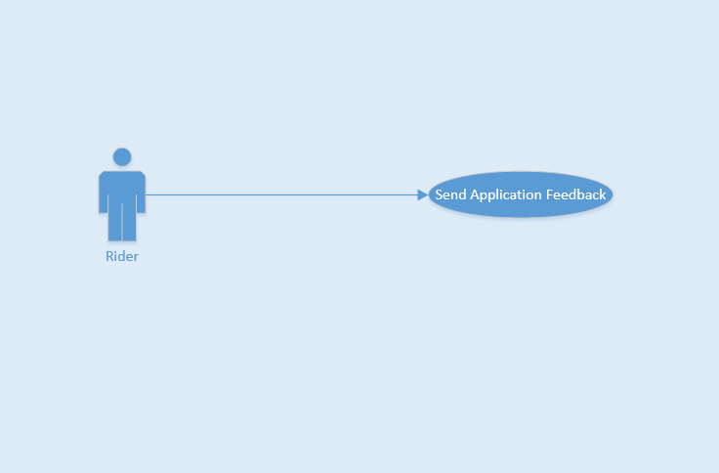
Use Case ID |  |  | UC-13
Use Name |  |  | Send Application Feedback
Actor |  |  | Rider
Description |  |  | This function allows Rider send feedback of application
Precondition |  |  | On Home Page screen
Trigger |  |  | Tap on feedback and enter textbox field
Post-Condition |  |  | Send feedback successful
Main flows
Step | Actor |  | Action
1 | Rider |  | On Home Page screen, tap on “Phản hồi” on left menu
2 | F-Taxi |  | Show two textbox field
3 | Rider |  | Enter “Tiêu đề” and “Nội dung” textbox field and tap on “Gửi” button
4 | F-Taxi |  | Send feedback successfull
Alternative flows
AT1 |  | At step 3 in the main flows, if Rider tap on back button
Step |  | Actor |  | Action
3.1 |  | F-Taxi |  | Back to Home Page screen

Business Rules
# | Rule Description
BR01 | Need Internet connection.

UC-14 Call Taxi Center
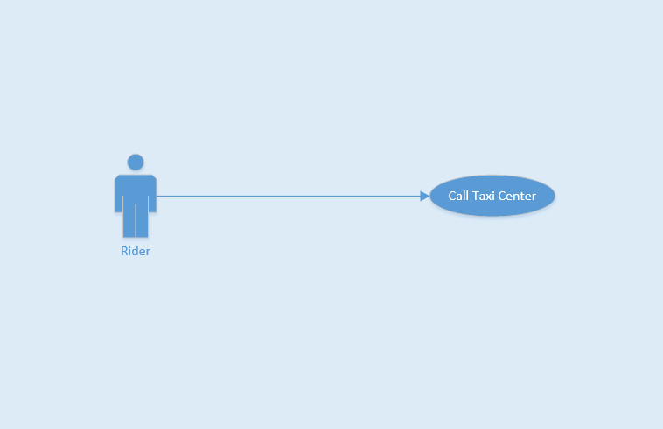
Use Case ID |  |  | UC-14
Use Name |  |  | Call Taxi Center
Actor |  |  | Rider
Description |  |  | This function allows Rider call taxi center when around without vehicle
Precondition |  |  | On Home Page screen
Trigger |  |  | Tap on red marker and choose the taxi company
Post-Condition |  |  | Call taxi center successful
Main flows
Step | Actor |  | Action
1 | Rider |  | On Home Page screen, tap on red marker name “Gọi hãng” on map screen
2 | F-Taxi |  | Show list taxi companies
3 | Rider |  | Choose taxi company and tap on logo taxi company to call
4 | F-Taxi |  | Call taxi center successful
Alternative flows
AT1 |  | At step 3 in the main flows, if Rider want search name of taxi company
Step |  | Actor |  | Action
3.1 |  | Rider |  | Enter character into search field
3.2 |  | F-Taxi |  | Return result of search for Rider

Business Rules
# | Rule Description
BR01 | Need Internet connection.

UC-15 Create Trip
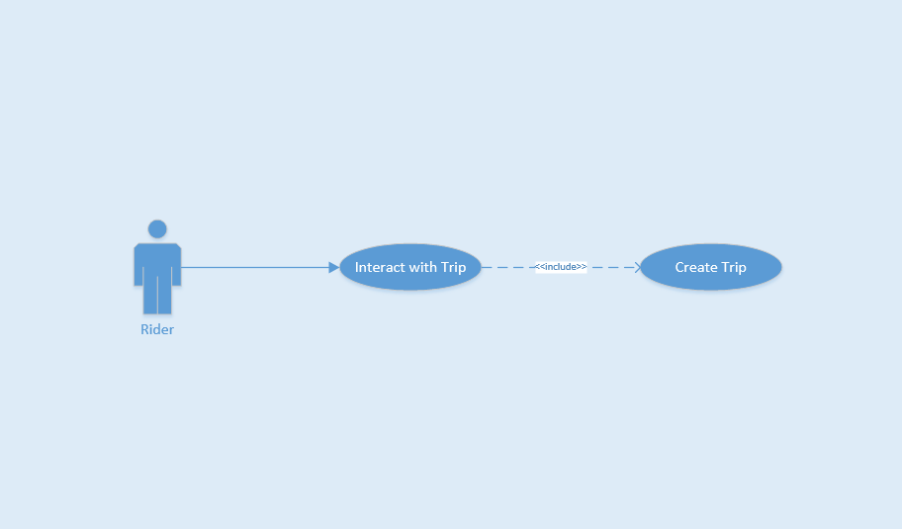
Use Case ID |  |  | UC-15
Use Name |  |  | Create Trip
Actor |  |  | Rider
Description |  |  | This function allows Rider create a trip
Precondition |  |  | Login and on Home Page screen
Trigger |  |  | Using finger to select or enter on field search address to pick up, then tap to call taxi
Post-Condition |  |  | Created Trip
Main flows
Step | Actor |  | Action
1 | Rider |  | Using finger to select or enter on field search address to pick up
2 | F-Taxi |  | Show Trip bar include Driver information and open price
3 | Rider |  | Tap on “Yêu cầu Taxi” button
4 | F-Taxi |  | Show "Vui lòng đợi..." message, Driver accepted, then show "Xe đang tới..." message and Driver started trip, show "Chúc bạn một chuyến đi vui vẻ" message and created trip
Alternative flows
AT1 |  | At step 1 in the main flows, if Rider enter wrong address field
Step |  | Actor |  | Action
1.1 |  | F-Taxi |  | Show ""Địa chỉ không hợp lệ, vui lòng thử lại!"" message on screen
AT2 |  | At step 1 in the main flows, if around has no taxi
Step |  | Actor |  | Action
1.2 |  | F-Taxi |  | Show "Không có taxi nào gần đây, vui lòng thử lại sau!" message on screen
AT3 |  | At step 1 in the main flows, if Rider have promotion code
Step |  | Actor |  | Action
1.1 |  | F-Taxi |  | Show Enter Promotion page screen
1.2 |  | Rider |  | Enter “Mã khuyến mại” textbox and tap on “Xác nhân” button
AT4 |  | At step 4 in the main flows, if Driver rejected request from Rider
Step |  | Actor |  | Action
4.1 |  | F-Taxi |  | Show "Yêu cầu bị hủy bỏ!" message on screen

Business Rules
# | Rule Description
BR01 | Need Internet connection.

UC-16 Cancel Trip
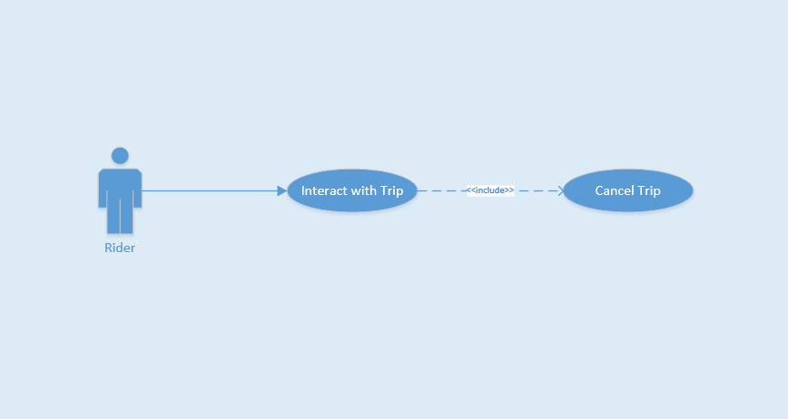
Use Case ID |  |  | UC-16
Use Name |  |  | Cancel Trip
Actor |  |  | Rider
Description |  |  | This function allows Rider cancel a trip
Precondition |  |  | Login and on Home Page screen
Trigger |  |  | Using finger to select or enter on field search address to pick up, then tap to call taxi. During time wait taxi response. Tap cancel
Post-Condition |  |  | Canceled Trip
Main flows
Step | Actor |  | Action
1 | Rider |  | Using finger to select or enter on field search address to pick up
2 | F-Taxi |  | Show Trip bar include Driver information and open price
3 | Rider |  | Tap on “Yêu cầu Taxi” button
4 | F-Taxi |  | Created Trip
5 | Rider |  | Tap on ”Hủy” red button
6 | F-Taxi |  | Show "Yêu cầu bị hủy bỏ!" message, Canceled Trip
Alternative flows
Step |  | Actor |  | Action

Business Rules
# | Rule Description
BR01 | Need Internet connection.

UC-17 List Complete Trip
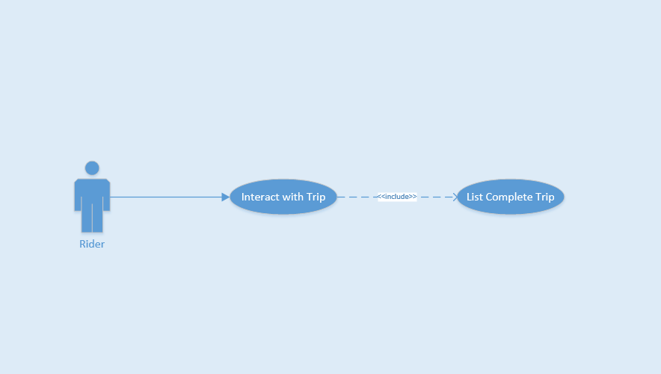
Use Case ID |  |  | UC-17
Use Name |  |  | List Complete Trip
Actor |  |  | Rider
Description |  |  | This function allows Rider view list completed trip
Precondition |  |  | On Home Page screen
Trigger |  |  | Tap on list complete trip button on left menu
Post-Condition |  |  | Show list complete trip successful
Main flows
Step | Actor |  | Action
1 | Rider |  | On Home Page Screen, them tap on “Lịch sử chuyến đi” on left menu
2 | F-Taxi |  | Show list complete trip successful
3 | Rider |  | Tap on “Xem chi tiêt”
4 | F-Taxi |  | Show detail trip
Alternative flows
AT1 |  | At step 2 in the main flows, if Rider have no trip before
Step |  | Actor |  | Action
2.1 |  | F-Taxi |  | Show "Bạn chưa có chuyến đi nào cả!" message

Business Rules
# | Rule Description
BR01 | Need Internet connection.

UC-18 View Bill Detail
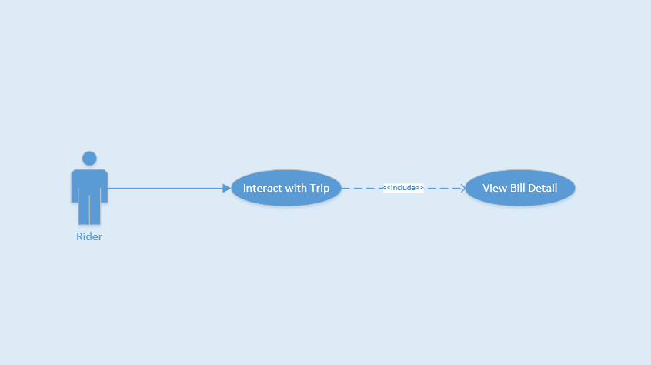
Use Case ID |  |  | UC-18
Use Name |  |  | View Bill Detail
Actor |  |  | Rider
Description |  |  | This function allows Rider view bill detail of trip
Precondition |  |  | Finished Trip
Trigger |  |  | Tap on “Kết thúc” button
Post-Condition |  |  | Show bill detail successful
Main flows
Step | Actor |  | Action
1 | Driver |  | Tap on “Hoàn thành chuyến đi” button
2 | F-Taxi |  | Show bill detail on screen Rider and Driver
Alternative flows
Step |  | Actor |  | Action

Business Rules
# | Rule Description
BR01 | Need Internet connection.

UC-19 Rate Driver
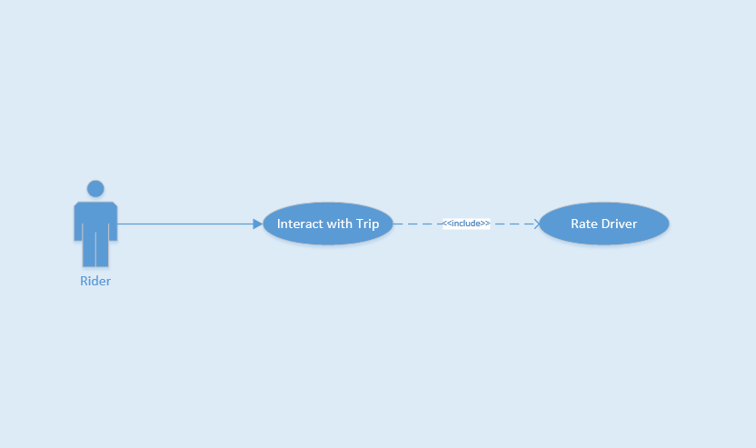
Use Case ID |  |  | UC-19
Use Name |  |  | Rate Driver
Actor |  |  | Rider
Description |  |  | This function allows Rider rate Driver after every trip
Precondition |  |  | Finished Trip
Trigger |  |  | Using finger choose from 1 to 5 star
Post-Condition |  |  | Rate Driver completed
Main flows
Step | Actor |  | Action
1 | F-Taxi |  | Show bill detail after finished trip
2 | Rider |  | Using finger choose from 1 to 5 star
3 | F-Taxi |  | Rate Driver completed
4 | Rider
Alternative flows
Step |  | Actor |  | Action

Business Rules
# | Rule Description
BR01 | Need Internet connection.

Driver

UC-20 Login
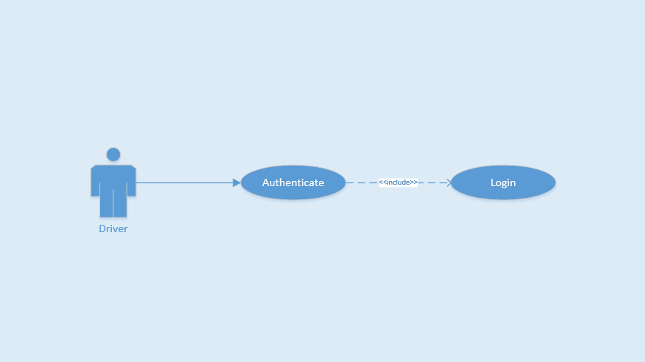
Use Case ID |  |  | UC-20
Use Name |  |  | Login
Actor |  |  | Driver
Description |  |  | This function allows a Rider to be able to login the application when he/she have registered an account and his/her account is active
Precondition |  |  | Start screen
Trigger |  |  | Input email and password correctly in the right textbox then tap on “Đăng nhập” button
Post-Condition |  |  | Login successfully
Main flows
Step | Actor |  | Action
1 | Driver |  | Tap on “Bỏ qua để đăng nhập” button on Start screen
2 | F-Taxi |  | Display Login screen with the following fields:  - Email  - “Mật khẩu”  - “Đăng nhập” button  - “Quên mật khẩu?” text block
3 | Driver |  | Enter Email and “Mật khẩu” fields on the Login screen, then tap on “Đăng nhập” icon.
4 | F-Taxi |  | Validate the entered Email and “Mật khẩu” and then display Home screen
Alternative flows
AT1 |  | At step 4 in the main flows, if F-Taxi failed to validate username and password
Step |  | Actor |  | Action
4.1 |  | F-Taxi |  | Display "Login" page with message "Email hoặc mật khẩu không đúng”

Business Rules
# | Rule Description
BR01 | Email must match xxx@xxx.xxx form
BR02 | Password must be show as asterisk (*******) type
BR03 | Need Internet connection.

UC-21 Logout
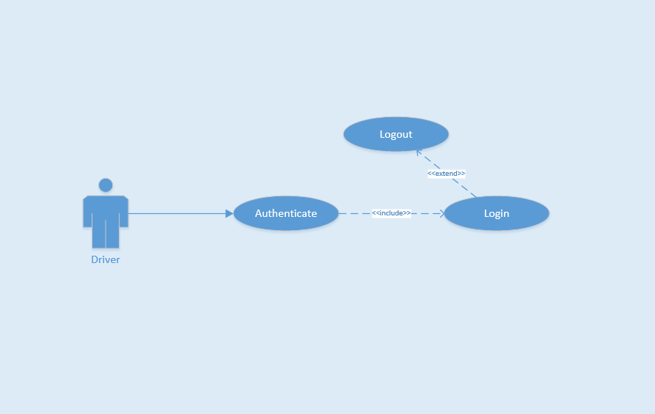
Use Case ID |  |  | UC-21
Use Name |  |  | Logout
Actor |  |  | Driver
Description |  |  | This function allows a Driver to logout F-Taxi
Precondition |  |  | Login
Trigger |  |  | Tap on back button or tap on “Đăng xuất” icon in menu bar, and then tap “Có” or tap on “Đăng xuất” icon and then tap “Có”
Post-Condition |  |  | Logout successfully
Main flows
Step | Actor |  | Action
1 | Driver |  | On Home screen, tap on back button or tap on “Đăng xuất” icon in menu bar
2 | F-Taxi |  | Display confirm message box with message “Bạn có muốn thoát không?”
3 | Driver |  | Tap “Có” option on message box
4 | F-Taxi |  | Log user out and display Login screen
Alternative flows
AT1 |  | At step 3 in the main flows, if Driver tap “Không” option on message box
Step |  | Actor |  | Action
3.1 |  | F-Taxi |  | Display "Login" page with message "Email hoặc mật khẩu không đúng”

Business Rules
# | Rule Description
BR01 | Need Internet connection.

UC-22 Forget Password
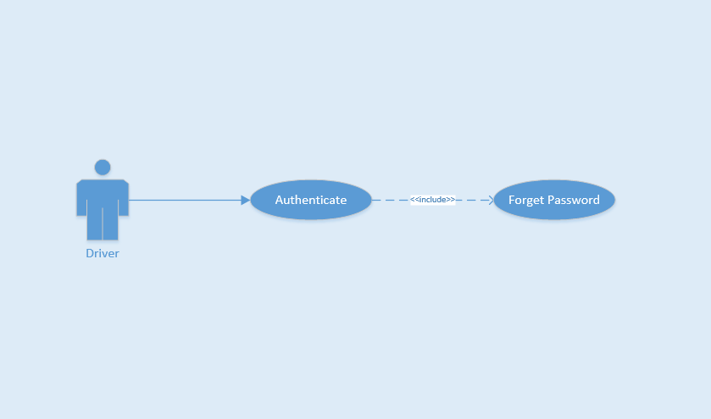
Use Case ID |  |  | UC-22
Use Name |  |  | Forget Password
Actor |  |  | Driver
Description |  |  | The function allows an Driver create new password
Precondition |  |  | Start app
Trigger |  |  | Tap on “Quên mật khẩu?” text on Login screen
Post-Condition |  |  | Reset password and create new password
Main flows
Step | Actor |  | Action
1 | Driver |  | On Login screen, tap on “Quên mật khẩu?” text
2 | F-Taxi |  | Display Forget Password screen
3 | Driver |  | Enter email to Email field, tap on “Đặt lại mật khẩu” icon
4 | F-Taxi |  | Send email confirm for Driver
Alternative flows
AT1 |  | At step 3 in the main flows, if Driver tap back button
Step |  | Actor |  | Action
3.1 |  | F-Taxi |  | Display "Login" screen

Business Rules
# | Rule Description
BR01 | Need Internet connection.

UC-23 View Profile
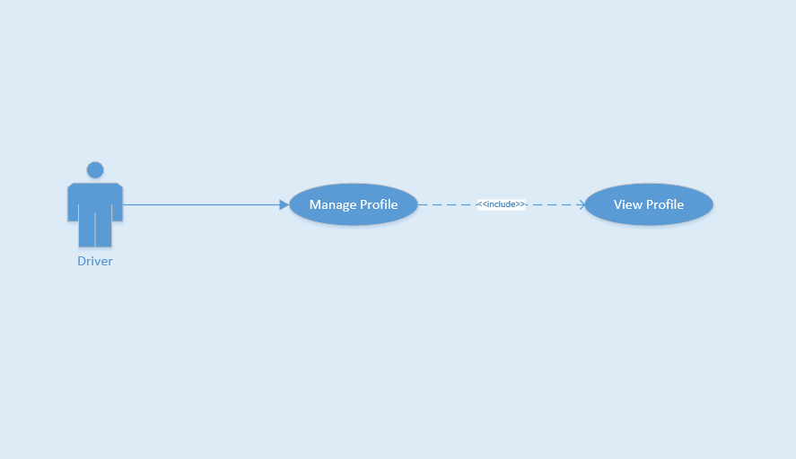
Use Case ID |  |  | UC-23
Use Name |  |  | View Profile
Actor |  |  | Driver
Description |  |  | This function allows Driver view profile
Precondition |  |  | Login and on Home Page Screen
Trigger |  |  | Tap on top left menu and then tap on image or name of Driver
Post-Condition |  |  | View successful
Main flows
Step | Actor |  | Action
1 | Rider |  | In Home Page screen, tap on top left menu
2 | F-Taxi |  | Show list left menu
3 | Driver |  | Tap on image or name of Driver
4 | F-Taxi |  | View successful
Alternative flows
AT1 |  | At step 3 in the main flows, if Driver tap button back
Step |  | Actor |  | Action
3.1 |  | F-Taxi |  | Back to Home Page Screen

Business Rules
# | Rule Description
BR01 | Need Internet connection.

UC-24 Update Profile
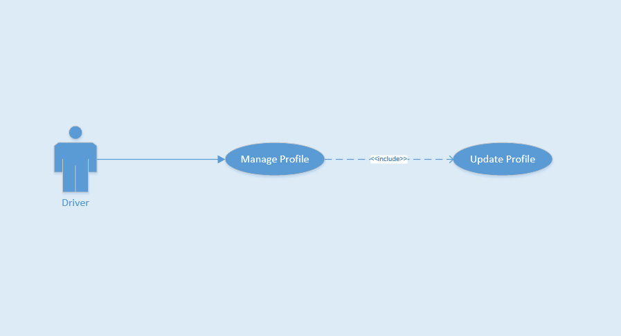
Use Case ID |  |  | UC-24
Use Name |  |  | Update Profile
Actor |  |  | Driver
Description |  |  | The function allows Driver to change their profile
Precondition |  |  | Login and on Home Page Screen
Trigger |  |  | Tap on field want to change and update field
Post-Condition |  |  | Updated successfully
Main flows
Step | Actor |  | Action
1 | Driver |  | On Home Page screen, tap on avatar or name of menu bar
2 | F-Taxi |  | Display Profile screen
3 | Driver |  | Tap on field want to change and update field, then tap on “Lưu” button.
4 | F-Taxi |  | Display message notice changed successfully. Stayed on Driver Profile page
5 | Driver |  | Tap on pencil image to change home or work address
6 | F-Taxi |  | Show Add Home Place or Add Work Place page
7 | Driver |  | Enter address textbox and choose right place from suggest to auto complete address
8 | F-Taxi |  | Show marker on maps.
9 | Driver |  | Tap on “Lưu lại” button
10 | F-Taxi |  | Display message notice changed successfully
Alternative flows
AT1 |  | At step 3 in the main flows, if Driver enter wrong information form
Step |  | Actor |  | Action
3.1 |  | F-Taxi |  | Display message box remind Driver insert again

Business Rules
# | Rule Description
BR01 | Need Internet connection.

UC-25 Change Password
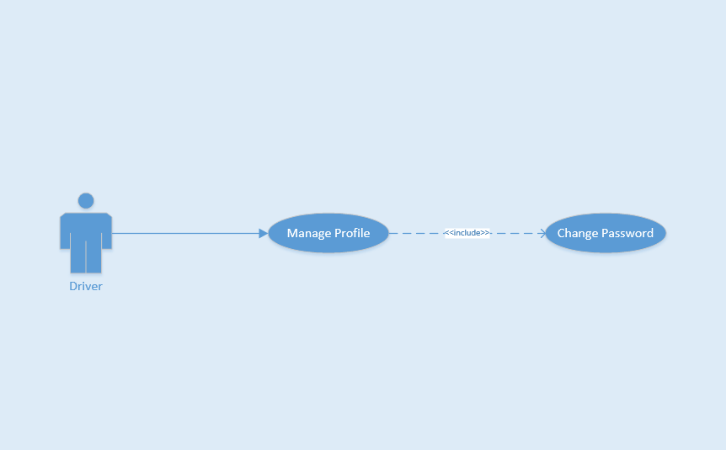
Use Case ID |  |  | UC-25
Use Name |  |  | Change Password
Actor |  |  | Driver
Description |  |  | The function allows a Driver to change their password
Precondition |  |  | Login and on Home Page Screen
Trigger |  |  | Tap on “Đổi mật khẩu” text and enter all field to change, then tap on “Xác nhận thay đổi” icon.
Post-Condition |  |  | Changed successfully
Main flows
Step | Actor |  | Action
1 | Driver |  | On Home Page screen, tap on avatar or name on left menu
2 | F-Taxi |  | Display Profile screen
3 | Driver |  | Tap on “Đổi mật khẩu” text
4 | F-Taxi |  | Display Change password screen with the following fields:  - “Mật khẩu cũ”  - “Mật khẩu mới”  - “Nhập lại mật khẩu mới”
5 | Driver |  | Enter “Mật khẩu cũ”, “Mật khẩu mới”, “Nhập lại mật khẩu mới” field on Change Password screen and then tap on “Đặt lại mật khẩu”.
6 | F-Taxi |  | Display a message box notice changed successfully
Alternative flows
AT1 |  | At step 4 in the main flows, if Driver insert wrong format pasword
Step |  | Actor |  | Action
4.1 |  | F-Taxi |  | Display message box remind Driver insert again

Business Rules
# | Rule Description
BR01 | Need Internet connection.

UC-26 Company Info
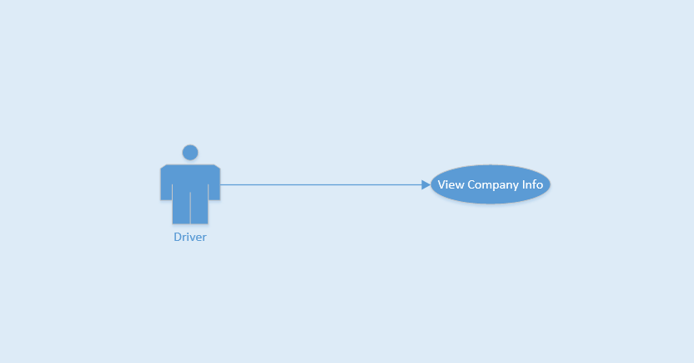
Use Case ID |  |  | UC-26
Use Name |  |  | Company Info
Actor |  |  | Driver
Description |  |  | This function allows Rider view company info
Precondition |  |  | Login and on Home Page screen
Trigger |  |  | Tap on company info
Post-Condition |  |  | View successful
Main flows
Step | Actor |  | Action
1 | Driver |  | On Home Page screen, tap on “Thông tin công ty” on left menu
2 | F-Taxi |  | Show information of company Driver
3 | Driver |  | View successfully
Alternative flows
Step |  | Actor |  | Action

Business Rules
# | Rule Description
BR01 | Need Internet connection.

UC-27 List Vip Customer
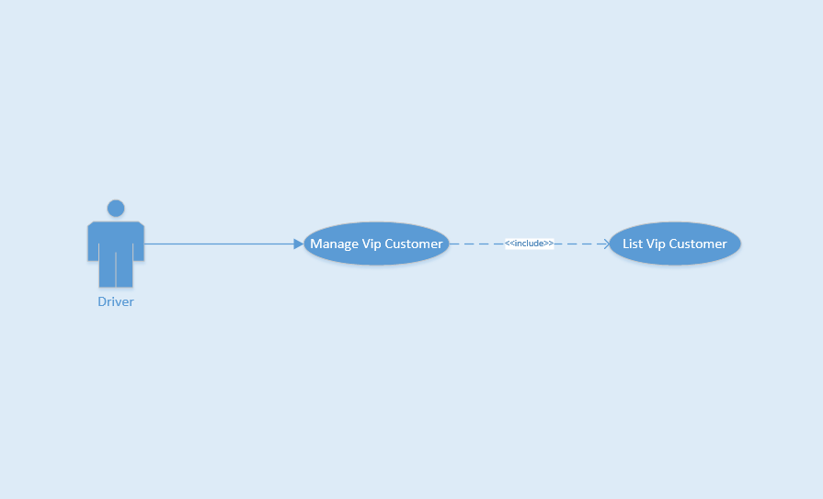
Use Case ID |  |  | UC-27
Use Name |  |  | List Vip Customer
Actor |  |  | Driver
Description |  |  | This function allows Rider
Precondition
Trigger
Post-Condition
Main flows
Step | Actor |  | Action
1 | Driver
2 | F-Taxi
3 | Driver
4 | F-Taxi
Alternative flows
Step |  | Actor |  | Action

Business Rules
# | Rule Description
BR01 | Need Internet connection.

UC-28 Add Vip Customer
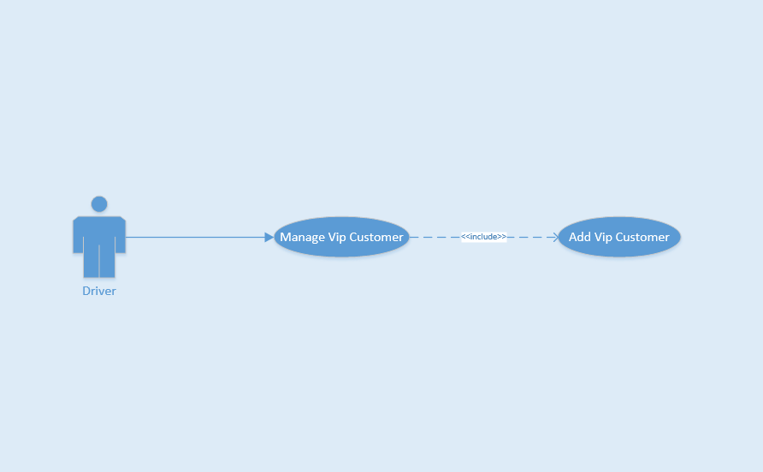
Use Case ID |  |  | UC-28
Use Name |  |  | Add Vip Customer
Actor |  |  | Driver
Description |  |  | This function allows Rider
Precondition
Trigger
Post-Condition
Main flows
Step | Actor |  | Action
1 | Driver
2 | F-Taxi
3 | Driver
4 | F-Taxi
Alternative flows
Step |  | Actor |  | Action

Business Rules
# | Rule Description
BR01 | Need Internet connection.

UC-29 Delete Vip Customer
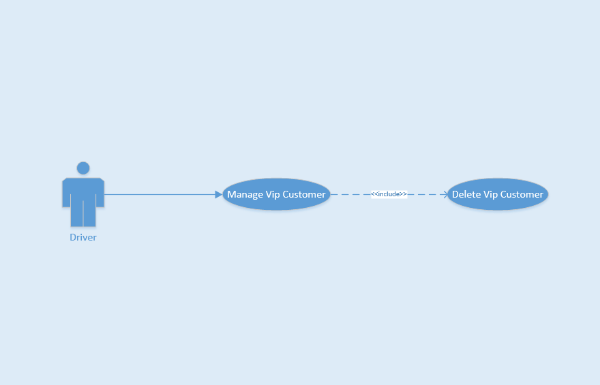
Use Case ID |  |  | UC-29
Use Name |  |  | Delete Vip Customer
Actor |  |  | Driver
Description |  |  | This function allows Rider
Precondition
Trigger
Post-Condition
Main flows
Step | Actor |  | Action
1 | Driver
2 | F-Taxi
3 | Driver
4 | F-Taxi
Alternative flows
Step |  | Actor |  | Action

Business Rules
# | Rule Description
BR01 | Need Internet connection.

UC-30 Notification Lost Asset
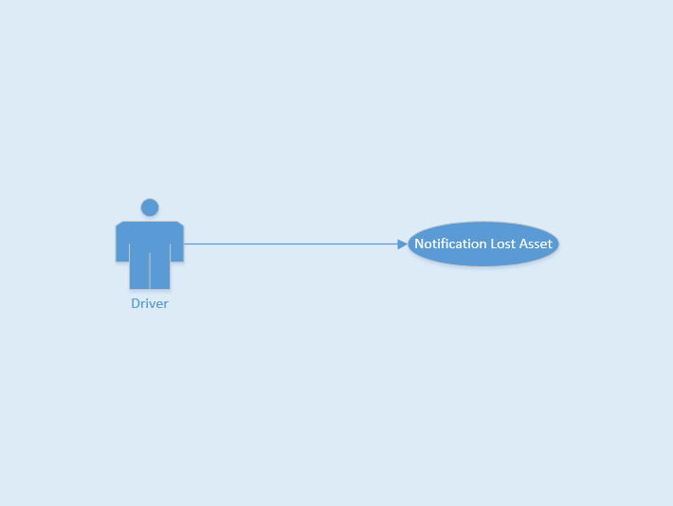
Use Case ID |  |  | UC-30
Use Name |  |  | Notification Lost Asset
Actor |  |  | Driver
Description |  |  | This function allows Rider
Precondition |  |  | On Home Page screen
Trigger |  |  | Tap on list complete trip button on left menu, and tap on trip lost asset
Post-Condition |  |  | Send message successfull
Main flows
Step | Actor |  | Action
1 | Driver |  | On Home Page screen, tap on “Lịch sử của tôi” on left menu
2 | F-Taxi |  | Show list complete trip
3 | Driver |  | Choose a trip and tap on, then tap on “Báo nhặt được đồ” button
4 | F-Taxi |  | Show textbox field
5 | Driver |  | Enter textbox field and tap on “Gửi” button
6 | F-Taxi |  | Send message successfull
Alternative flows
Step |  | Actor |  | Action

Business Rules
# | Rule Description
BR01 | Need Internet connection.

UC-31 Change Status
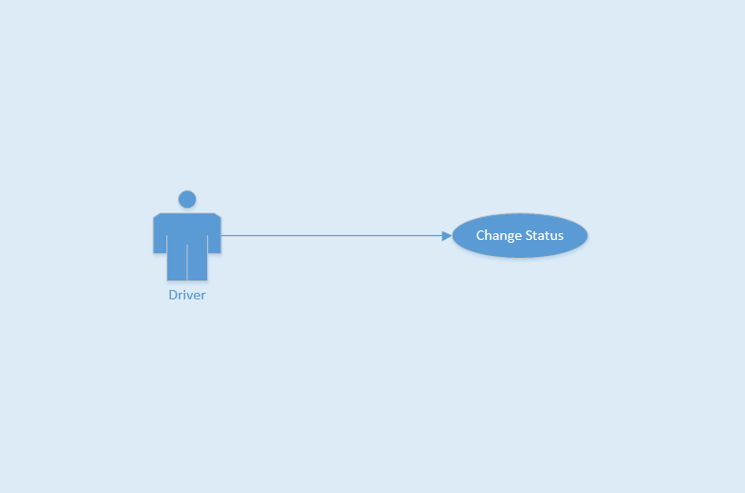
Use Case ID |  |  | UC-31
Use Name |  |  | Change Status
Actor |  |  | Driver
Description |  |  | This function allows Driver change status not available when Driver want off time work day
Precondition |  |  | Login and on Home Page screen
Trigger |  |  | Tap on change status button or logout application
Post-Condition |  |  | Changed Status
Main flows
Step | Actor |  | Action
1 | Driver |  | On Home Page screen
2 | F-Taxi |  | Tap on “Nhấn để chuyển qua trạng thái nghỉ” button or logout application
3 | Driver |  | Changed Status
Alternative flows
Step |  | Actor |  | Action

Business Rules
# | Rule Description
BR01 | Need Internet connection.

UC-32 Accept Trip
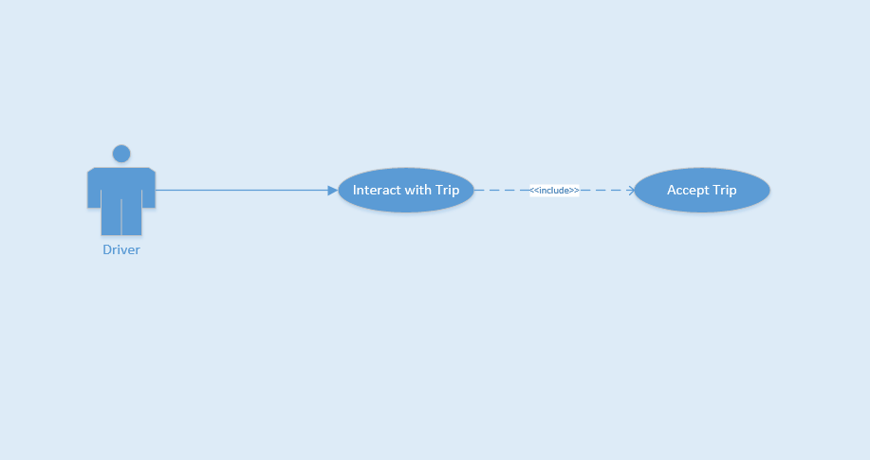
Use Case ID |  |  | UC-32
Use Name |  |  | Accept Trip
Actor |  |  | Driver
Description |  |  | This function allows Driver accepted request from Rider call
Precondition |  |  | Login
Trigger |  |  | Dialog box show up and Driver tap on “Đồng ý” button
Post-Condition |  |  | Driver accepted trip and pick up Rider
Main flows
Step | Actor |  | Action
1 | F-Taxi |  | Send notification and request from Rider to Driver, show dialog box
2 | Driver |  | Tap on “Đồng ý ” button
3 | F-Taxi |  | Driver accepted trip and pick up Rider
Alternative flows
Step |  | Actor |  | Action

Business Rules
# | Rule Description
BR01 | Need Internet connection.

UC-33 Reject Trip
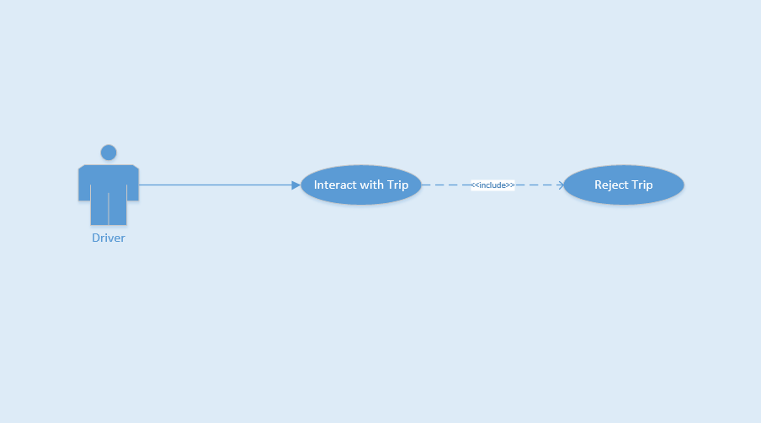
Use Case ID |  |  | UC-33
Use Name |  |  | Reject Trip
Actor |  |  | Driver
Description |  |  | This function allows Driver rejected request from Rider call
Precondition |  |  | Login
Trigger |  |  | Dialog box show up and Driver tap on “Từ chối” button
Post-Condition |  |  | Driver rejected trip from Rider
Main flows
Step | Actor |  | Action
1 | F-Taxi |  | Send notification and request from Rider to Driver, show dialog box
2 | Driver |  | Tap on “Từ chối ” button
3 | F-Taxi |  | Driver rejected trip from Rider
Alternative flows
Step |  | Actor |  | Action

Business Rules
# | Rule Description
BR01 | Need Internet connection.

UC-34 Start Trip
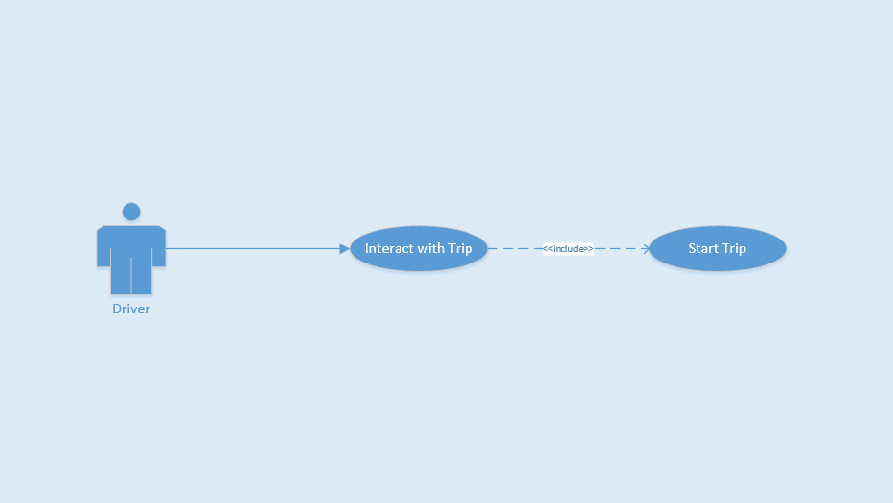
Use Case ID |  |  | UC-34
Use Name |  |  | Start Trip
Actor |  |  | Driver
Description |  |  | This function allows Driver start a trip after accepted Rider request
Precondition |  |  | Accepted Rider request
Trigger |  |  | Tap on start trip for start calculate fee and distance
Post-Condition |  |  | Started Trip
Main flows
Step | Actor |  | Action
1 | F-Taxi |  | Show dialog box before Driver picked up Rider
2 | Driver |  | When Rider on taxi, tap on “Bắt đầu” button
3 | F-Taxi |  | Started Trip
Alternative flows
Step |  | Actor |  | Action

Business Rules
# | Rule Description
BR01 | Need Internet connection.

UC-35 Cancel Trip
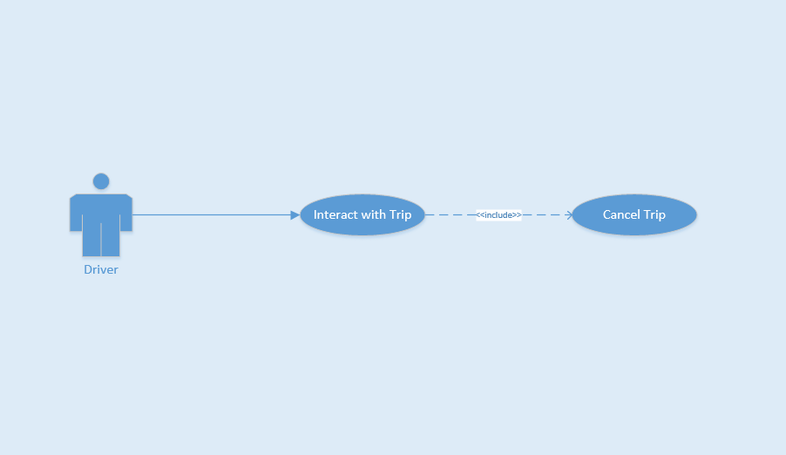
Use Case ID |  |  | UC-35
Use Name |  |  | Cancel Trip
Actor |  |  | Driver
Description |  |  | This function allows Driver cancel a trip after accepted Rider request
Precondition |  |  | Accepted Rider request
Trigger |  |  | Tap on cancel trip when change decision
Post-Condition |  |  | Canceled Trip
Main flows
Step | Actor |  | Action
1 | F-Taxi |  | Show dialog box before Driver picked up Rider
2 | Driver |  | When Driver change decision, tap on “Hủy” button
3 | F-Taxi |  | Canceled Trip
Alternative flows
Step |  | Actor |  | Action

Business Rules
# | Rule Description
BR01 | Need Internet connection.

UC-36 Complete Trip
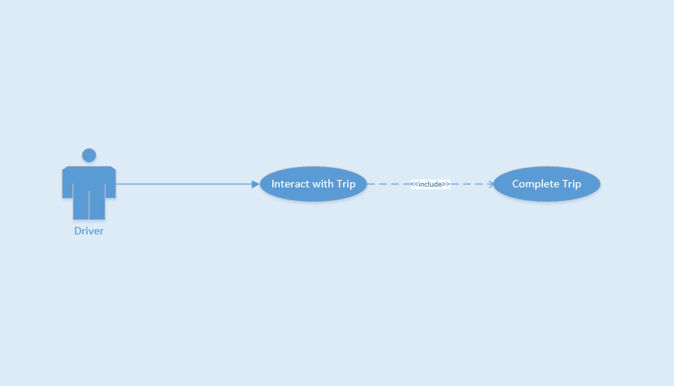
Use Case ID |  |  | UC-36
Use Name |  |  | Complete Trip
Actor |  |  | Driver
Description |  |  | This function allows Driver view list completed trip
Precondition |  |  | On Home Page screen
Trigger |  |  | Tap on list complete trip button on left menu
Post-Condition |  |  | Show list complete trip successful
Main flows
Step | Actor |  | Action
1 | Driver |  | On Home Page Screen, them tap on “Lịch sử của tôi” on left menu
2 | F-Taxi |  | Show list complete trip successful
3 | Driver |  | Tap on “Xem chi tiêt”
4 | F-Taxi |  | Show detail trip
Alternative flows
Step |  | Actor |  | Action

Business Rules
# | Rule Description
BR01 | Need Internet connection.

UC-37 View Bill Detail
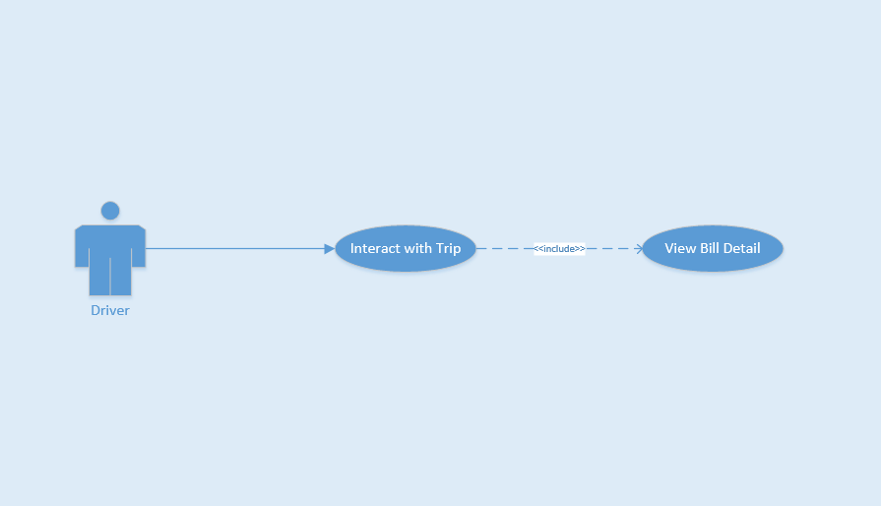
Use Case ID |  |  | UC-37
Use Name |  |  | View Bill Detail
Actor |  |  | Driver
Description |  |  | This function allows Driver view bill detail of trip
Precondition |  |  | Finished Trip
Trigger |  |  | Tap on “Chạm để thanh toán” button
Post-Condition |  |  | Show bill detail successful
Main flows
Step | Actor |  | Action
1 | Driver |  | Tap on “Chạm để thanh toán” button
2 | F-Taxi |  | Show bill detail on screen Driver
3 | Driver |  | Tap on “Thanh toán” button and receive payment from Rider
4 | F-Taxi |  | Show bill detail on screen Rider
Alternative flows
Step |  | Actor |  | Action

Business Rules
# | Rule Description
BR01 | Need Internet connection.

Non-functional Requirement

Reliability
- Passwords must be encoded in database as MD5 type.

Performance Requirement

Availability
- Application must available 95% of time.
- Users can access to application everywhere from windows mobile device with internet connection.

Response time
- Time for loading content is 3-5 seconds depend on speed of internet.
- Time to process function will not exceed 7 seconds.

Usability
- User can easy take a trip in few tap on screen.
- Support Vietnamese for user can easy understand.

Hardware/Software Requirements
- Hardware requirement: Window mobile with Windows Phone 8.0.
- Software requirement: Download application from Windows Store and using it with internet connection.

